**Independent University, Bangladesh**



**Project Draft Report**

**Course Title:** Database Management

**Course Code:** CSE 303

**Section:** 04

**Prepared for:** Ms. Sadita Ahmed

**Prepared By:**

Mohammad Arshad Hossain Ratul (1930319)

Tunisha Yanoor Bristy (1930639)

Refat Ahmed Bhuiyan (1930053)

Nahin Islam (1930577)

Tasnia Tabassum Oishee (1910040)

Sadia Islam Semi (1930127)

Department of Computer Science & Engineering

School of Engineering, Technology & Science

Independent University, Bangladesh

STUDENT ENROLLMENT AND REVENUE ANALYSIS

Contents

Chapter 1 5

Introduction 5

A: Background of the Organization: 5

B: Background of the Project: 5

C: Objectives of the Project: 5

D: Scope of the project: 6

Chapter 2 7

Requirement Analysis 7

A: Rich Picture of existing business system 7

B: Existing Six system elements 8

C: Business Process Diagram (AS-is) 13

D: PROBLEM ANALYSIS of the EXISTING BUSINESS SYSTEM 15

E: Rich picture of Proposed Business System 17

F: Proposed Six system elements 18

G: Business Process Diagram (TO-BE) 24

CHAPTER 3 27

Logical System Design 27

A: BUSINESS RULES 27

B: Entity Relation Diagram (ERD) 28

C: Relational schema 29

D: Normalization 30

E: Data Dictionary 31

Table of Figures

Figure 1: Rich Picture AS-IS 7

Figure 2:Prepare revenue table and chart for each School (AS-IS) 13

Figure 3: Comparative analysis of the number of sections in each school (AS-IS) 13

Figure 4: Provide course and section informations to iRAS (AS-IS) 13

Figure 5: Information of student enrollment (AS-IS) 14

Figure 6: Prepare classroom requirement summary (AS-IS) 14

Figure 7: Analysis of percentage of unused resources (AS-IS) 14

Figure 8: Rich picture of proposed system 17

Figure 9: Prepare revenue table and chart for each school (TO-BE) 24

Figure 10: Analysis of number of section (TO-BE) 24

Figure 11: Provide course and section information to SEARIS (TO-BE) 24

Figure 12: Information of student enrollment (TO-BE) 25

Figure 13: Prepare classroom requirement summary (TO-BE) 25

Figure 14: Analysis of percentage of unused resources for each school (TO-BE) 25

Figure 15: Comparative analysis of number sections offered in SETS (TO-BE) 26

Figure 16: Upload tally sheet and revenue information (TO-BE) 26

Figure 17: Entity Relation Diagram 28

Figure 18: Relational Schema 29

Figure 19: Normalization 30

# Chapter 1

## Introduction

### A: Background of the Organization:

Independent University, Bangladesh(IUB) is one of the first private universities of Bangladesh. It was established in 1993. Currently around 8,423 students are enrolled in IUB. Moreover, IUB currently has 13,745 alumni and 401 faculty members who are contributing to outstanding research in a variety of fields. IUB conducts its academics through various Schools. Currently, IUB has 5 Schools:

1. School of Entrepreneurship and Business.
2. School of Engineering, Technology and Sciences.
3. School of Environment and Life Sciences.
4. School of Liberal Arts and Social Sciences.
5. School of Pharmacy and Public Health.

Under each School, there are several departments. Currently, IUB has a total of 12 departments. As per the world university rankings of Times Higher Education (THE) IUB stands within 400th universities globally in terms of various aspects of impact analysis. Moreover, IUB provides various types of scholarships to encourage the students in academics. With the help of well-equipped laboratories as well as an enormous library, students and researchers get to invest their knowledge efficiently.

### B: Background of the Project:

This project is used to analyze the enrollment process of a specific organization.This project focuses on decreasing the manual labor for tasks. Moreover, various kinds of users for an organization like IUB can use the software to view information. Both the enrollment data and revenue information are stored in the database. In addition, detailed data of all the courses for each department is added including credit hour, course ID, currently enrolled students, etc. The data stored can be used to generate various charts and tables in order to view the information required. In the enrollment process we can see the information of course’s course name, course ID, course section, maximum capacity, enrolled capacity, class time and days. There is information available such as faculty name, faculty ID, classroom number, school name and others. The project works by taking an input from the user through which it can generate charts/tables that the user wants to view.

### C: Objectives of the Project:

The objective of our project is to perform some of the significant tasks that need to be done repeatedly. With the help of this project, the time consuming tasks that are done manually are done within a short span of time. The basic functions of this project are:

* Store the enrollment information of students of each Semester for each School and Department.
* Analyze the revenue of each School for selected Semesters as well to view the percentage change in revenue for each School from a specific semester to another.
* Generate the classroom requirement for each day for a specific number of slots.
* Analyze the resources of IUB by observing the amount of unused resources.

With the help of this software, the human interference in these vital tasks are reduced and hence, the results are more precise as it has less chance of errors. Moreover, by automating the tasks, the time can be utilized elsewhere. In addition, data can be accessed easily.

Although building a software like this might seem expensive but on a larger scale considering doing the same tasks manually, it is more efficient and less costly to go for automated processes.

### D: Scope of the project:

This project is giving out solutions to enrollment issues and revenue changes. This project is helping students, faculty, department managers and others to use this web app for data:

* storing
* editing
* adding
* updating
* viewing

We designed possible users for the web-based system for the users and imagined how they would use it, as well as the information and data they would require.

We will create customized user interfaces and login capabilities for all participants who will be users of this system, because problems might develop at any stage in any business process.

We use this system for data storage, so obtaining relevant files, tabular data, formats, and reports is really simple, and we can interact with the data in real time.

We also build user interfaces that allow all users to quickly access data and generate and download reports.

# Chapter 2

## Requirement Analysis

### A: Rich Picture of existing business system

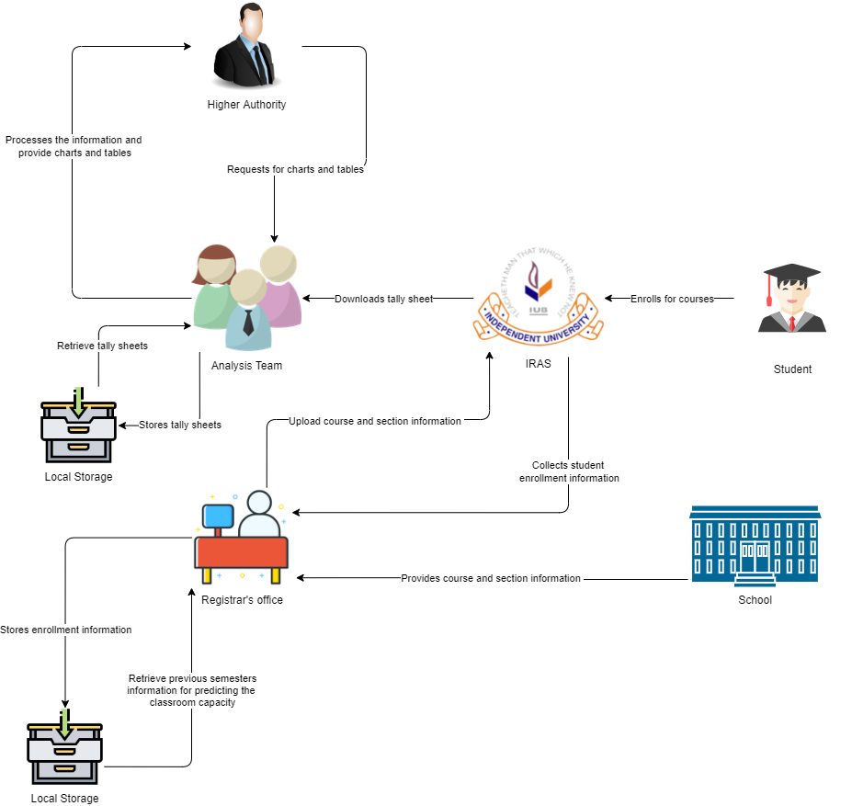

Figure 1: Rich Picture AS-IS

### B: Existing Six system elements

|  |  |  |  |  |  |  |
| --- | --- | --- | --- | --- | --- | --- |
| **Process** | **System Roles** | | | | | |
| **Human** | **Non-Computing**  **Hardware** | **Computing**  **Hardware** | **Software** | **Database** | **Network & communication** |
| **Prepare revenue table and chart for each School** | **Higher authorities:**  1.Request the analysis team for the revenue table and chart for particular semesters via email.  2. Receive tables and charts from the analysis team via email.  **Analysis team:**  1.Receive email from the higher authority to send tables and charts.  2.Check the local storage to fetch data.  3.If data is not found, then use iRAS to download the data.  4.. Login to Iras.  5. Download the tally sheet from iras.  6.Process table and chart from the tally sheets.  7.  Sends the charts and tables to the higher authorities via email.  8.Store tally sheets to the local storage. | **Paper:**  1.Used to print the chart and table. | **Computer:**  1. Analysis team Used to login to iras.  2. Used to Download the tally sheet from iras.  **Printer :**  1. To print out the chart and data from the table | **Iras:**  1. Analysis team use iras to download the tables and charts in the excel file  **Microsoft Excel:**  1.Excel Sheets are used by Higher authorities to read the table and chart.  Gmail:  1. Used to send and receive emails. | **Local Storage:**  1. Analysis team use a local storage to store the tally sheets. | **Internet:**  1. The Internet is used to Communicate with IRAS to browse the software/ webpage where the analysis team can download required tally sheets.  2. To access email. |
| **Comparative analysis of the number of sections in each school** | **Higher Authority:**  1. Send an email with a set range to the analysis team to prepare an analysis report for each school where the number of students enrolled is less than the given range.  2. Receives the report.  Analysis team:  1. Receives an email from the higher authorities.  2. Analyzes  the given task.  3. Retrieves the needed tally sheet from its local storage.  4. If not stored previously then downloads the tally sheet from Iras.  3. Prepare the report in excel sheet.  4. Stores the  tally sheet in local storage.  5. Send the report to the higher authorities. | **Paper:**  1. Used to print the hardcopy if needed. | **Computer:**  1. Used to login iRAS.  2. For preparing the comparative analysis sheet.  3. Download the analysis sheet from iRAS.  **Printer:**  1. To print out the analysis sheet. | **iRAS:**  1. The Analysis team uses iRAS to get the information.2.Register office uses iRAS to download the analysis sheet.  **Gmail:**  1. Used to send and receive emails. | **Local Storage:**  1. Analysis team uses a local storage to store the  tally sheets.  2.  Analysis team uses a local storage to fetch the previously stored tally sheets. | **Internet:**  1. Used to send and receive emails.  2. Used to access Iras. |
| **Provide course and section informations to iRAS** | **School:**  1. Emails course and section information to the registrar’s office.  **Registrar's office:**  1. Receives chart information about course and section.  2.Retrieve previous semesters  information for predicting the  classroom capacity.  3. Uploads predicted course and section capacity,  to Iras. | **Paper:**  1. Used for keeping hardcopy of the information. | **Computer:**  1.For preparing the information sheet.  2. Sending emails. | **iRAS:**  1.Used by the registrar’s office to upload data..  **Microsoft Excel:**  1. Used to make the required information list by the school.  2. Used to make the predicted list by the register’s office.  Gmail:  1. To email the course and section information to the registrar’s office. | **Local Database:**  1. Used by registrar’s office to store  the hardcopy of data. | **Internet:**  1. To access iRAS. |
| **Information of student enrollment** | **Student:**  1.Enrolls for courses in iras.  iRAS:  1.Collects information regarding enrollment.  2.Sends information to the Registrar's Office.  **Registrar’s Office:**  1.Receiving the enrollment information.  2. Sending to local storage for storing the information.  Local Storage:  1.Receiving the information and storing the enrollment information. | **Paper:**  1.Print the information if needed. | **Printer:**  1.Printer is used to print the information into hardcopy.  **Computer:**  1.Computer is used to enroll for the courses through iRAS.  2.Sending information from iRAS to the registrar's office. | **iRAS:**  1.iRAS is used to access enrollment.  **Gmail:** 1.It is used to send enrollment information to the registrar’s office | **Local Storage:**  1.Information has been sent to the local storage from the registrar’s office to store the information. | **Internet:**  1.Internet is used to access iRAS for enrollment by students.  2.Internet is used to send enrollment information to the registrar's office by iRAS. |
| **Prepare classroom requirement summary** | **Higher Authority:**  1.Emails the analysis team to prepare a classroom requirement summary as per the class size desired.  2. Receives the information.  **Analysis Team:**  1.Receives email to prepare classroom requirement summary via email.  2. Analyzes the number of slots per day.  3. Prepares classroom requirement summary as per the class size provided as a Chart.  4.Email the chart to the higher authority. | **Paper:**  1.Used to store the hardcopy of classroom requirement summary. | **Computer:**  1.To receive and send emails  2.To make the charts required. | **Gmail:**  1. To receive and send email  **Microsoft Excel:**  1.To prepare the classroom requirement summary on a chart. | **Local Database:**  1.Used to store the summary for future references. | **Internet:**  1.Used to send email and receive email. |
| **Analysis of percentage of unused resources** | **Analysis Team:**  1. Receives email from the higher authorities.  2. Look for the needed tally sheets.  3. If the tally sheet is stored in the local storage then fetch the data. 4. If the tally sheet is not present then login to iras and download the required tally sheet.  5. Calculate the percentage of unused resources.  6. Produce a report.  7. Send the report to the higher authorities.  **Higher authorities:**  1. Asks the analysis team to make a report for unused of each school via email.  2. Asks the analysis team to make a report for the total unused percentage for the university overall based on average enrollment per section versus average capacity per room. | **Paper:**  1. To store a hard copy of the report. | **Computer:**  1. To make the report. | **Microsoft Excel:**  1. To generate the report.  **Gmail:**  1. To email the Analysis team to ask for the report.  2. To email the report to the higher authorities. | **Local Database:**  1. Used by the analysis team to store the report of unused resources. | **Internet:**  1. To access iras.  2. To mail. |

### C: Business Process Diagram (AS-is)

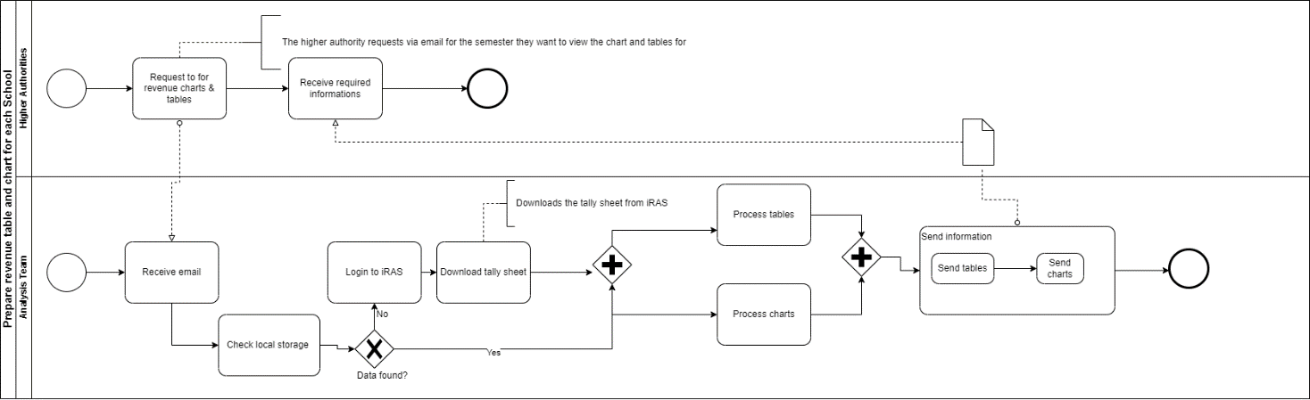

Figure 2:Prepare revenue table and chart for each School (AS-IS)

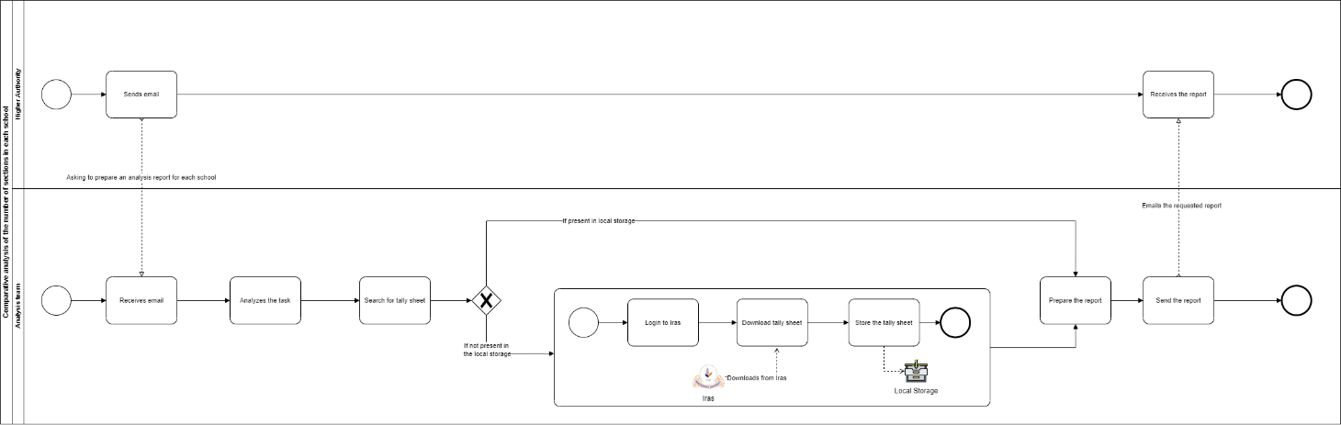

Figure 3: Comparative analysis of the number of sections in each school (AS-IS)

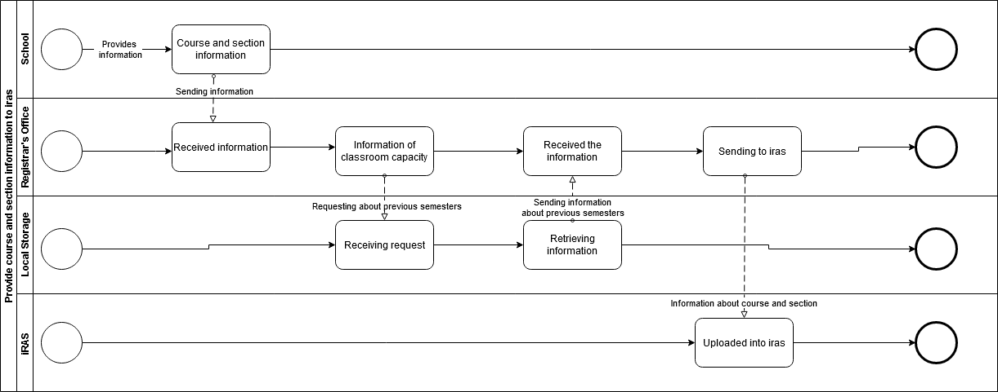

Figure 4: Provide course and section informations to iRAS (AS-IS)

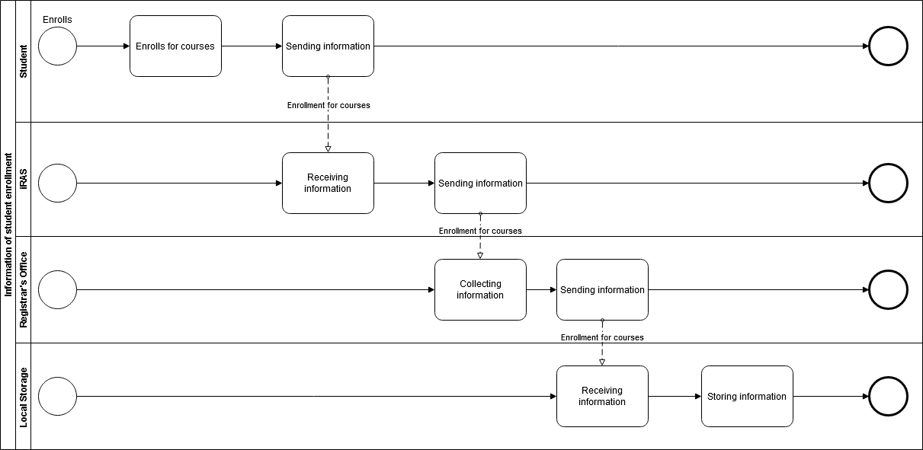

Figure 5: Information of student enrollment (AS-IS)

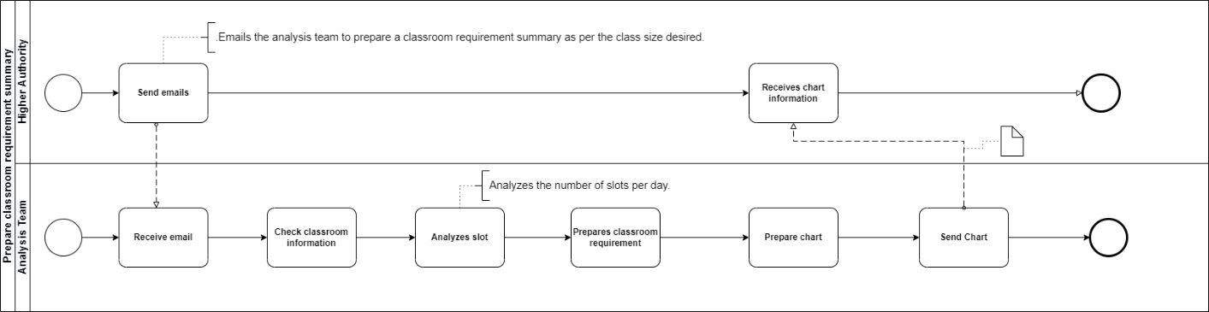

Figure 6: Prepare classroom requirement summary (AS-IS)

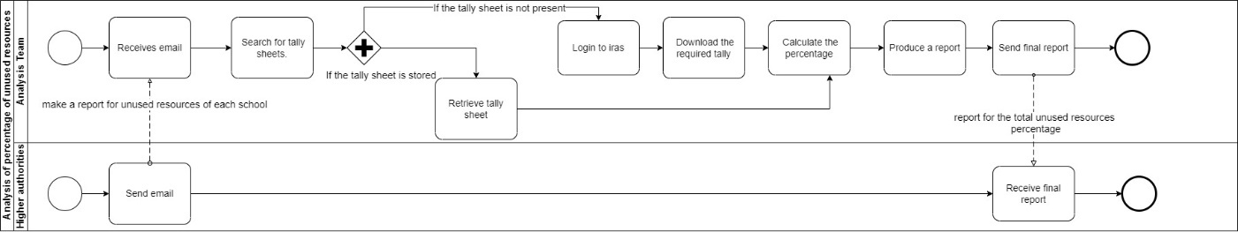

Figure 7: Analysis of percentage of unused resources (AS-IS)

### D: PROBLEM ANALYSIS of the EXISTING BUSINESS SYSTEM

|  |  |  |  |  |
| --- | --- | --- | --- | --- |
| **Process Name** | **Stakeholders** | **Concerns (Problems)** | **Analysis (Reason of the Problems)** | **Proposed Solution** |
| Prepare revenue table and chart for each School | 1.Higher Authority  2.Analysis Team | The process is time consuming | The communication is done via email as the higher authorities have to send an email first if they want to view the information. After they have sent the email, then the analysis team prepares the revenue table which takes a lot of time. | The system will automatically generate charts and tables so that the delay in between the tasks can be avoided. This way, the higher authority can view the information within a few seconds. |
| Comparative analysis of the number of sections in each school | 1.Higher Authority  2.Analysis Team | Delay in receiving the analysis | As the communication is done via email, the process is slower. In addition, the analysis team has to go through the local storage first to retrieve the required tally sheets and if they are unable to find it then they have to login to iRAS to download the tally sheet.All these tasks are extremely time consuming and there can be errors in between as well. | The tally sheets can be stored in the system and then whenever an user wants to view the analysis, the system would automatically calculate it.Hence, delays are avoided and it is more precise since there are no manual searches to be done |
| Prepare classroom requirement summary | 1.Higher Authority  2.Analysis Team | The process is time consuming | The communication is done via email as the higher authorities have to send an email first if they want to view classroom requirement summary. After they have sent the email, then the analysis team analyzes the number of slots per day and make a chart about classroom requirement | The system will automatically generate the required charts from user requests so that the delay in between the tasks can be avoided. This way, the higher authority can view the information within a few seconds from the website. |
| Analysis of percentage of unused resources | 1.Higher Authority  2.Analysis Team | Delay in the analysis | The communication is done via email, hence, the process becomes slower. In addition to this, the analysis team has to go through the local storage first to find the tally sheets and if they are unable to find, then they have to login to iRAS in order to download the tally sheet and then they have to make the analysis of the unused percentage of resources. After all these, they have to send the analysis to the higher authorities. This makes room for a lot of errors and also delays the tasks in between. | The system can be used to store the tally sheets and then whenever an user requests to view the analysis, the system can automatically generate charts from the tally sheets that are stored. This eliminates errors as well as delay. |

### E: Rich picture of Proposed Business System

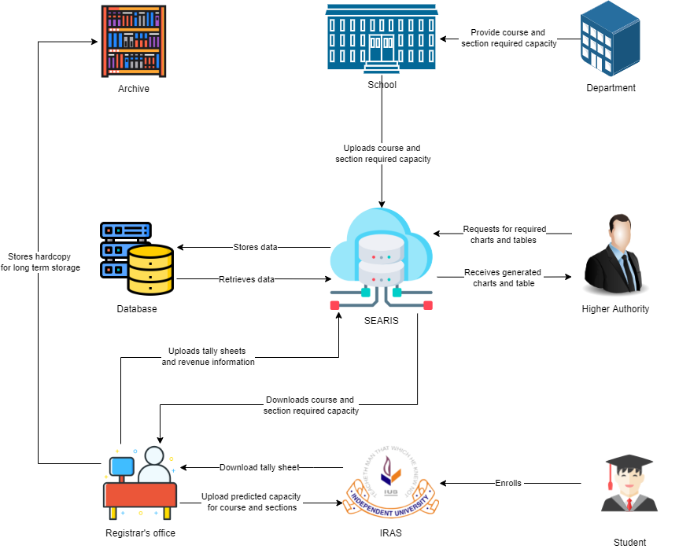

Figure 8: Rich picture of proposed system

### F: Proposed Six system elements

|  |  |  |  |  |  |  |
| --- | --- | --- | --- | --- | --- | --- |
| **Process** | **System Roles** | | | | | |
| **Human** | **Non-Computing Hardware** | **Computing Hardware** | **Software** | **Database** | **Network & communication** |
| **Prepare revenue table and chart for each school** | **Higher Authorities:**  1.Login to SEARIS.  2.Select “revenue particular semester”.  3.Enter “semester’’.  4.Click “Generate table and chart’’  5.View table and chart from    “SEARIS”.  6.If user wants to print the table and chart, He can click on the “Print” button. | **Paper:** Used to print the chart and table. | **Computer:**  1.Used to login to SEARIS.  2.Used to generate charts and  Table.  Printer: Used to print the chart and table. | **SEARIS:**  1.Higher authorities use “SEARIS’’ to view the revenue for a particular semester in a chart or table. | **SEARIS database:**  Used to fetch the required data to create a table and chart | **Internet:**  Used to access SEARIS. |
| **Analysis of the number of sections** | **Higher Authorities:**  1. Login to SEARIS.  2. Click “Analysis sections”.  3. Enter the range upto which the results will show.  4. Select the semesters for which the results will be shown.  5. Press “Show results”  6. The user sees the analysis of sections.  7. There will be an option ”Show detailed view”  which will show  detailed breakdown of the analysis.  8. If the user wants to change the range or the chosen semesters then the user needs to click the “back” button which will take the user to the interface where he needs to enter the range and semesters.  9. There will be an option for printing the analysis and also the breakdown, if the user wants to print. | **Paper:**  1. Used to print hardcopy. | **Computer:**  1. Used to access “SEARIS”  2. Used to see the analysis. | **SEARIS:**  1. Used to generate the analysis charts.  2. See the breakdown tables. | **SEARIS database:**  1. Used to fetch the required data to create the analysis chart and detailed breakdown table. | **Internet:**  1. Used to access “SEARIS”. |
| **Provide course and section information to SEARIS** | **School:**  1. Emails course and section information to the registrar’s office.  **Registrar's office:**  1. Receives chart information about course and section.  2.Retrieve previous semesters information for predicting the  classroom capacity.  3. Uploads predicted course and section capacity,  to Iras. | **Paper:**  1. Used for keeping hardcopy of the information. | **Computer:**  1.For preparing the information sheet.  2. Sending emails. | **iRAS:**  1.Used by the registrar’s office to download enrollment information.  **Microsoft Excel:**  1. Used to make the required information list by the school.  2. Used to make the predicted list by the register’s office.  **Gmail:**  1. To email the course and section information to the registrar’s office. |  | **Internet:**  1. To access iRAS. |
| **Information of student enrollment** | **Student:**  1.Enrolls for courses in iras.  iRAS:  1.Collects information regarding enrollment.  2.Sends information to  the Registrar's Office.  **Registrar’s Office:**  1.Receiving the enrollment information.  2. Sending to local storage for storing the information.  Local Storage:  1.Receiving the information and the store the enrollment information. | **Paper:**  1.Used to print the information. | **Printer:**  1.Printer is used to print the information into hardcopy.  **Computer:**  1.Computer is used to enroll for the courses through iRAS.  2.Sending information from iRAS to the registrar's office. | **iRAS:**  1.iRAS is used to access enrollment.  **Gmail:** 1.It is used to send enrollment information to the registrar’s office. | **Local Storage:**  1.Information has been sent to the local storage from the registrar’s office to store the information. | **Internet:**  1.Internet is used to access iRAS for enrollment by students.  2.Internet is used to send enrollment information to the registrar's office by iRAS. |
| **Prepare classroom requirement summary** | **Higher Authorities:**  1.Login to SEARIS.  2. Select “Classroom requirement summary”.  3.Enter class size.  4. Click the “generate chart” button.  5. View the chart of classroom requirement summary that is generated by SEARIS.  6.Select the “Print” button if they want to print the summary. | **Paper:** Used to print the summary if needed. | **Computer:**  1.Used to login to SEARIS.  2.Used to generate charts.  **Printer:**  1.Used to print the summary if required. | **SEARIS:**  1. Used to generate classroom requirement summary. | **SEARIS database:**  1.Contains the past data and with the help of that, a chart for classroom requirement summary is generated.  **Archive:** Contains data from the past. | **Internet:**  Used to access SEARIS. |
| **Analysis of percentage of unused resources for each school** | **Higher Authority:**  1.Login to SEARIS.  2.Click on the “View unused resources” button.  3.Select the semesters from the drop-down menu.  4.View the analysis.  5.Select the “Print” button to print the analysis if needed. | **Paper:**  1.Used to print the analysis if required. | **Computer:**  1.Used to login to SEARIS and view the analysis.  **Printer:**  1.Used to print the analysis if needed. | **SEARIS:**  1.Used to usegenerate tables by using the data stored in the database. | **SEARIS database:**  1.Contains all the past data which is used to generate tables. | **Internet:**  1.Used to access SEARIS. |
| **Comparative analysis of number sections offered in SETS** | **Higher Authorities:**  1.Login to SEARIS.  2.Click on "Analysis of number of sections offered”.  3. The user sees options for choosing the semester/s and the class size.  4. Choose the semester/s.  5.Choose the class size.  6. The user can select the range of class size among them.  7. Press the button "Show results".  8. It helps to see the results regarding the class size of the selected semester.  9. The user can also press the button "Print" to print the results if needed. | **Paper:**  1.The paper is used to print the charts. | **Computer:**  1.Computer is used to access the SEARIS and see the needed information.  **Printer:**  1.Printer is used to print the needed results. | **SEARIS:**  1.SEARIS is used to access to login to the software to see the needed results. | **SEARIS database:**  1. Used to fetch the required data to create the analysis chart. | **Internet:**  1.Internet is used to access SEARIS. |
| **Upload tally sheet and revenue information** | **Registrar’s Office:**  1.Login to iRAS.  2.Download tally sheet.  3. Login to SEARIS.  4. Select the “upload data” button.  5.Attach the file of the tally sheet and the file containing revenue information.  6.Click “confirm”.  7. Receive confirmation alert.  8. If the confirmation alert is not received, click confirm again. | **N/A** | **Computer:**  1.Used to login to SEARIS and iRAS to download the tally sheet and to upload the tally sheet and revenue information files. | **iRAS:**  1.Used to download the tally sheet.  **SEARIS:**  1.Used to upload the tally sheet and revenue information files. | **SEARIS database:**  1.Used to store the tally sheet and revenue information. | **Internet:**  1. Used to access SEARIS and iRAS. |

### G: Business Process Diagram (TO-BE)

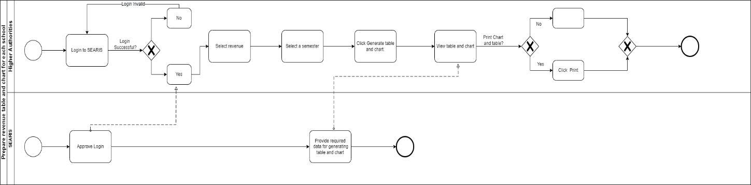

Figure 9: Prepare revenue table and chart for each school (TO-BE)

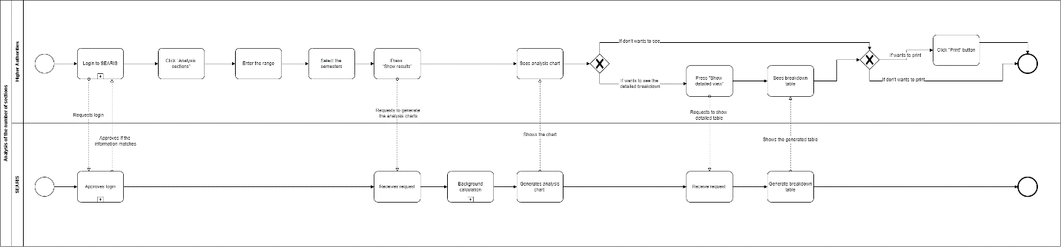

Figure 10: Analysis of number of section (TO-BE)



Figure 11: Provide course and section information to SEARIS (TO-BE)



Figure 12: Information of student enrollment (TO-BE)

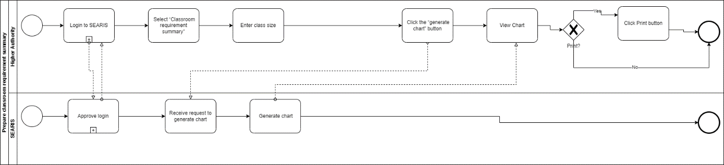

Figure 13: Prepare classroom requirement summary (TO-BE)

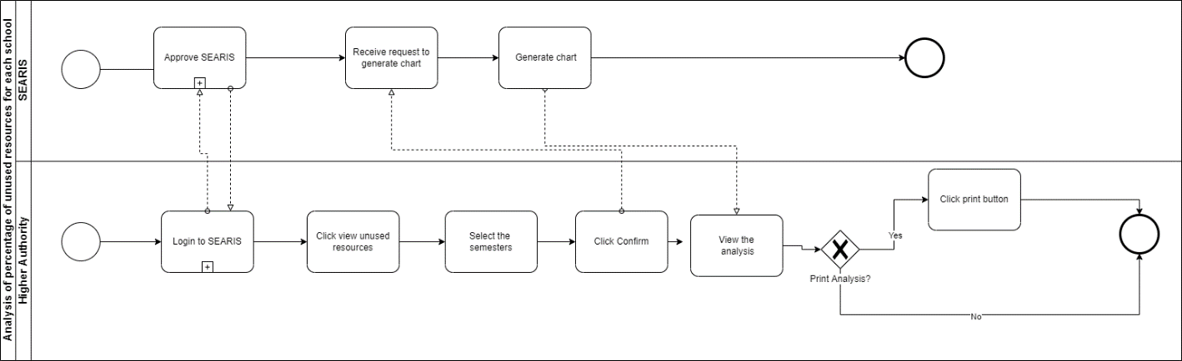

Figure 14: Analysis of percentage of unused resources for each school (TO-BE)

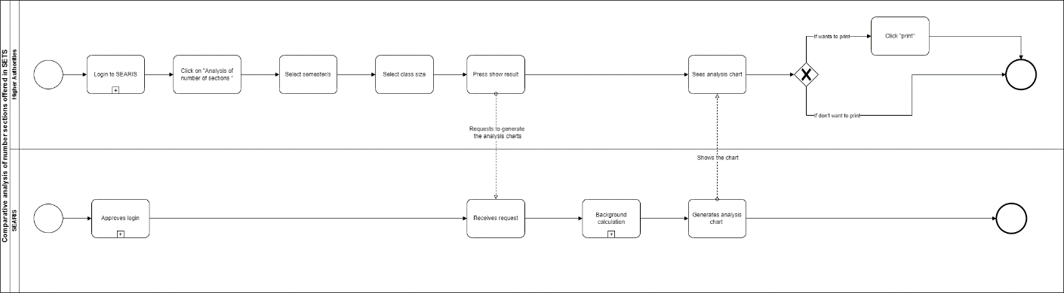

Figure 15: Comparative analysis of number sections offered in SETS (TO-BE)

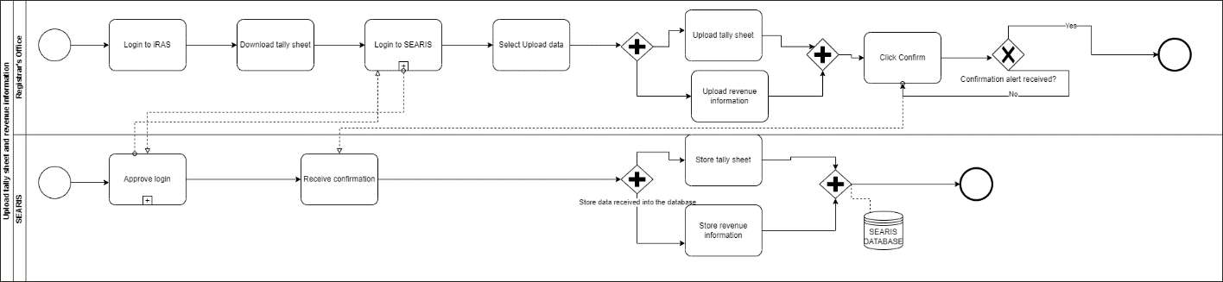

Figure 16: Upload tally sheet and revenue information (TO-BE)

# CHAPTER 3

## Logical System Design

### A: BUSINESS RULES

1. The academics of IUB consists of School and Department.
2. Each School has a unique identifier and name.
3. Each School consists of several Departments. A department must belong to a School and a School must have at least one or more departments.
4. Departments have departmentID to uniquely identify each department as well as department name.
5. Departments offer courses. A department must offer one or many courses. At least one course must belong to one department.
6. Courses have CourseID, number of credits, course name, number of sections, departmentID, classroomNumber, prerequisite.
7. A course must be taught by one Faculty. A faculty may take one or more courses.
8. One course must have at least one or more sections.
9. Faculty has facultyID, faculty name, courseID.
10. A section must have one Faculty assigned to a specific classroom. A Faculty can take one or more sections.
11. Courses are offered every semester. Semesters have a session and year.
12. Semesters can be identified using both session and year.
13. Sections have section number, courseID, semester session and year, classroomNumber, facultyID, maximum_capacity, enrolled_capacity, class_time which has the starting and ending time of a class as well as the number of days, blockedStatus.
14. A faculty can hand over a course of a specific section to another faculty for a particular semester.
15. Classrooms are assigned to a specific section based on the enrollment capacity.
16. Classrooms are used in slots. For IUB, it is 6 slots or 7 slots for each day.
17. A section is assigned to only one slot at a time.
18. Each course must have at least one slot per week. For some courses, it can be two slots per week.

### B: Entity Relation Diagram (ERD)

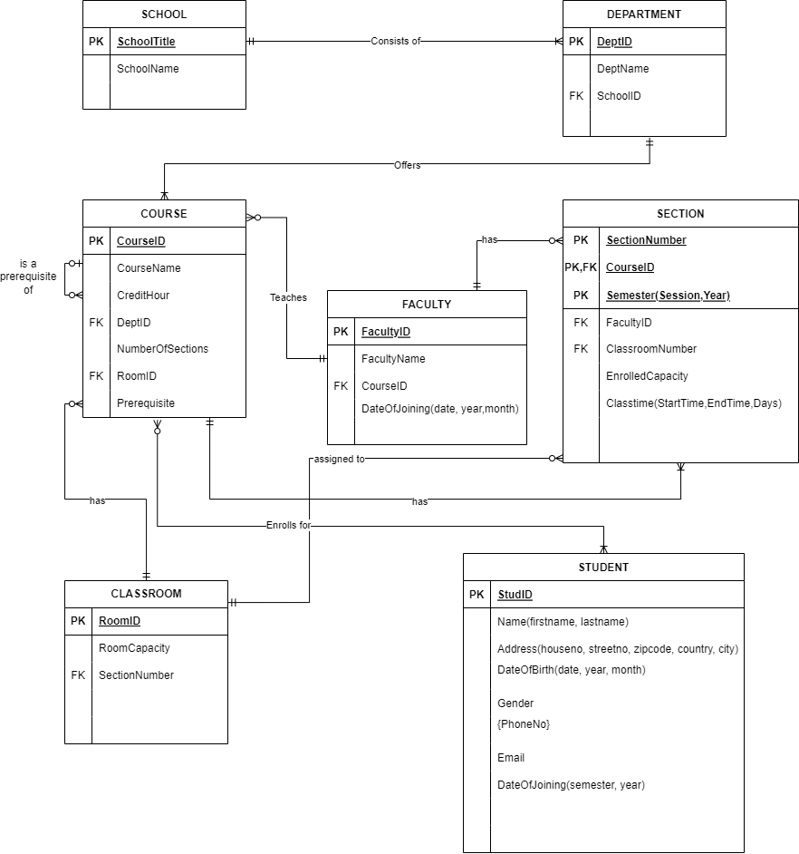

Figure 17: Entity Relation Diagram

### C: Relational schema

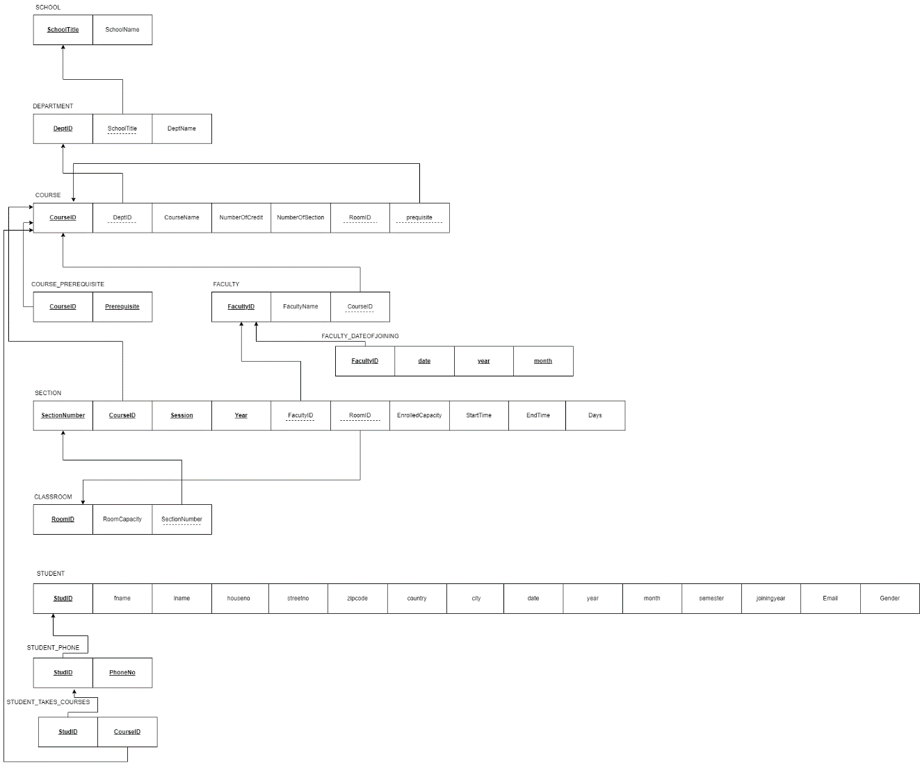

Figure 18: Relational Schema

### D: Normalization

DeptID DeptName, SchoolTitle

CourseID CreditHour, CourseName

DeptID, SectionNumber, CourseID, session, year FacuktyID, RoomID, EnrolledCapacity, StartTime, EndTime, Days

RoomID RoomCapacity, SectionNumber

SchoolTitle SchoolName

FacultyID FacultyName, date, year, month

Prequisite CourseID

StudID firstname,lastname,houseno,streetno,zipcode,country, city, date, year, month gender, email, semester, joiningyear

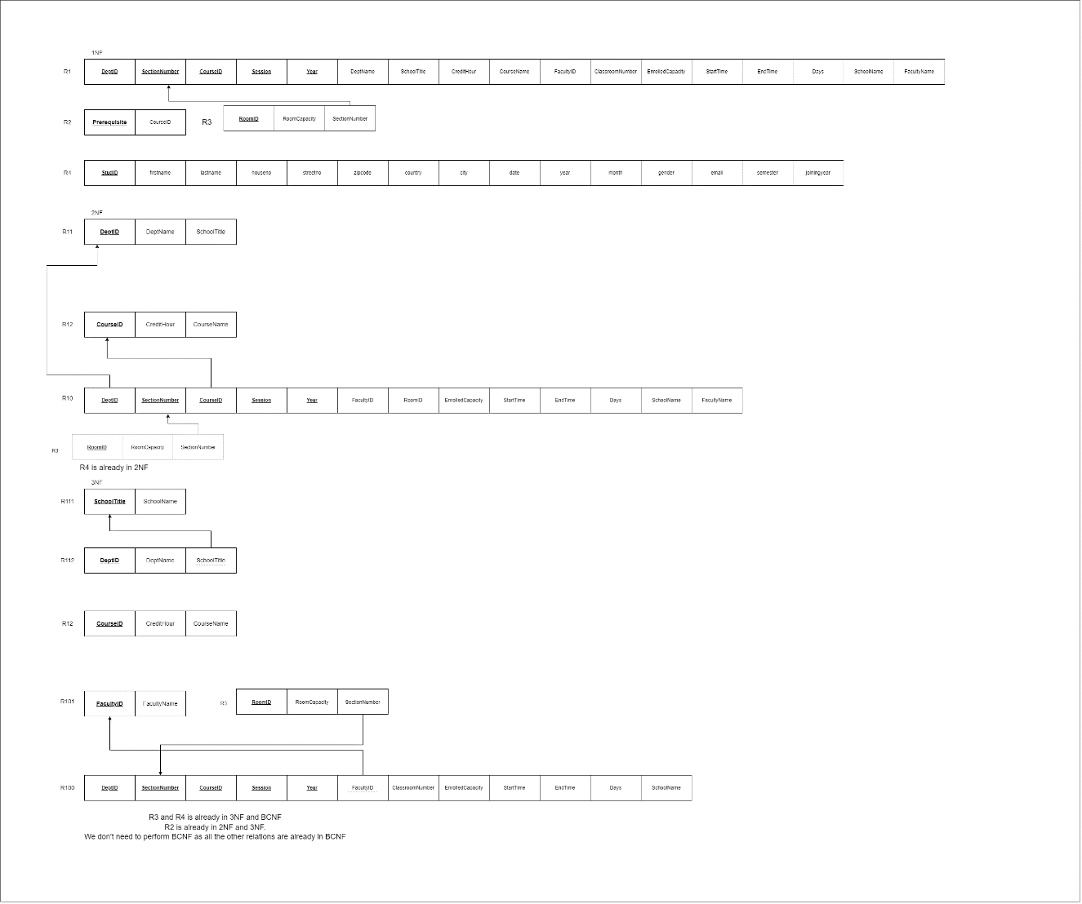

Figure 19: Normalization

### E: Data Dictionary

|  |  |  |  |
| --- | --- | --- | --- |
| Name | type | Size | Remark |
| SchoolTitle | VARCHAR | 6 | This is the primary  Key of this relation. It contains the ID of the school.  Ex: SETS |
| SchoolName | VARCHAR | 30 | This is the name of the school  Ex: School of engineering and technology. |

SCHOOL:

DEPARTMENT:

|  |  |  |  |
| --- | --- | --- | --- |
| NAME | TYPE | SIZE | REMARK |
| DeptID | VARCHAR | 5 | This is the primary key  Of this relation which contains the ID of dept  Ex: CSE, EEE |
| DeptName | VARCHAR | 30 | This is the name of dept.  Ex: Computer Science and Engineering. |
| SchoolID | VARCHAR | 6 | This is the foreign key from SCHOOL table. |

Course:

|  |  |  |  |
| --- | --- | --- | --- |
| NAME | TYPE | SIZE | REMARK |
| CourseID | VARCHAR | 10 | This is the primary key  Of this relation which contains the ID of course.  Ex: CSE303 |
| CourseName | VARCHAR | 30 | This is the name of course.  Ex: Database management system |
| CreditHour | NUMBER | 1 | It contains the number of credits for a course.  Ex: 3 credits for DBMS |
| DeptID | VARCHAR | 10 | This is the foreign key from Department table. |
| NumberOfSections | NUMBER | 3 | It contains number of sections.  Ex:4 Section in |
| RoomID | NUMBER | 6 | It contains the number of classrooms  Ex: 5 |
| Prerequisite | VARCHAR | 6 | It contains number of prerequisite courses.  Ex: 203 prerequisite 201 |

FACULTY:

|  |  |  |  |
| --- | --- | --- | --- |
| NAME | TYPE | SIZE | REMARK |
| FacultyID | VARCHAR | 4 | This is the primary key of the relation. It contains the Id of the faculty.  Ex:4242 |
| FacultyName | VARCHAR | 30 | It contains the name of the faculty.  EX: Ms. Sadita Ahmed |
| CourseID | VARCHAR | 7 | Course Id is the foreign  Key from COURSE table. |
| DateOfJoining | DATE | 3 | Stores the date |

SECTION:

|  |  |  |  |
| --- | --- | --- | --- |
| NAME | Type | Size | Remark |
| SectionNumber | NUMBER | 10 | This is the primary key of this relation.  It contains the total number of sections.  Ex: CSE 303 HAS 4 SECTIONS |
| CourseID | NUMBER | 10 | This is the primary key as well as a foreign key from COURSE table. |
| Session | VARCHAR | 15 | This is a primary key of this relation. It contains the session of the semester.  Ex: Summer |
| Year | NUMBER | 4 | Contains the year |
| FacultyID | NUMBER | 10 | Faculty ID is the foreign key from FACULTY table. |
| ClassroomNumber | NUMBER | 10 | Classroom number is a foreign key from CLASSROOM table. |
| EnrolledCapacity | NUMBER | 2 | It contains the number of enrolled capacity.  Ex: CSE303 has 30 seats |
| StartTime | VARCHAR | 6 | It contains the time and date of a course.  Ex:8AM |
| EndTime | VARCHAR | 6 | It contains the time and date of a course.  Ex: 11am |
| Days | VARCHAR | 2 | It contains the time and date of a course.  Ex: MW |

CLASSROOM:

|  |  |  |  |
| --- | --- | --- | --- |
| Name | Type | Size | Remark |
| RoomID | VARCHAR | 6 | This is the primary key of this relation it contains the classroomNumber.  Ex:BC5004 |
| MaxCapacity | NUMBER | 6 | It contains the maximm capacity of the class.  Ex: CSE303(30) |
| SectionNumber | NUMBER | 6 | This is a foreign key from SECTION. |

STUDENT:

|  |  |  |  |
| --- | --- | --- | --- |
| Name | Type | Size | Remark |
| StudID | NUMBER | 8 | To uniquely identify the entity.  Ex: 1930319 |
| firstname | VARCHAR | 20 | It contains the first name of the student.  Ex: Sadia |
| lastname | VARCHAR | 20 | It contains the last name of the student.  Ex: Semi |
| houseno | NUMBER | 5 | It contains the house number of the student. |
| streetno | NUMBER | 5 | It contains the street number of the student. |
| zipcode | NUMBER | 4 | It contains the zip code number of the student.  Ex: 1200 |
| country | VARCHAR | 50 | It contains the name of the country of the student.  Ex: Bangladesh |
| city | VARCHAR | 50 | It contains the name of the city of the student.  Ex: Dhaka |
| DateofBirth | DATE | 3 | It contains the date of birth of the student.  Ex: 1999-02-01 |
| Gender | CAHR | 1 | It contains the name of the gender of the student.  Ex: M/F/T |
| Email | VARCHAR | 100 | It contains the email of the student. |
| DateOfJoining | DATE | 3 | It contains the date of joining of the student. |